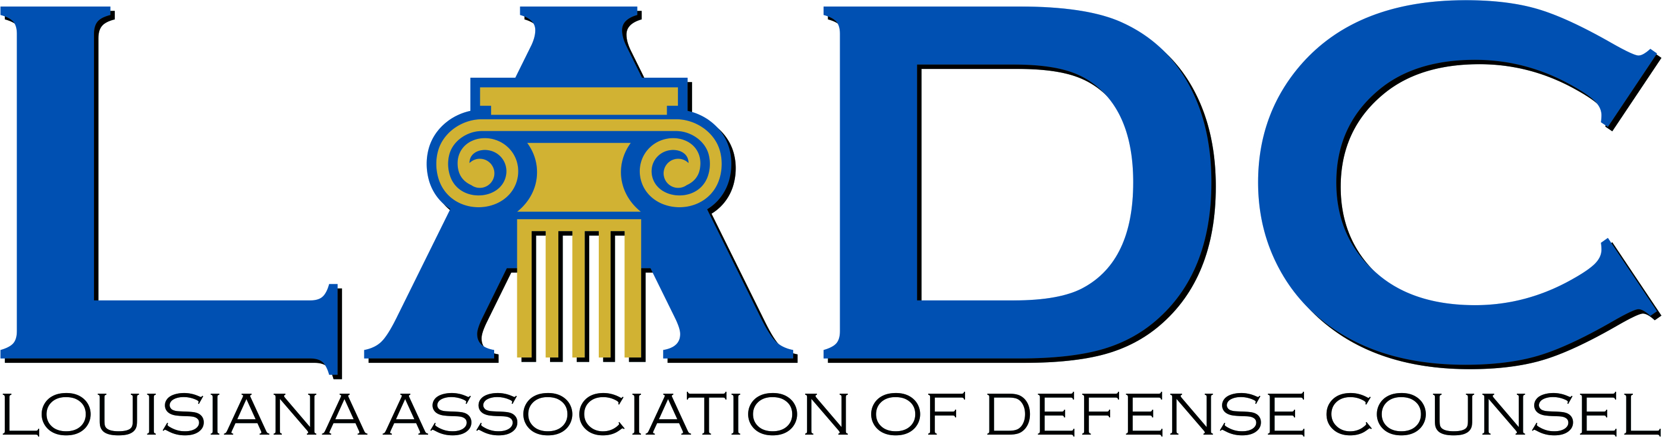

Louisiana Judicial College and
Louisiana Association of Defense Counsel Joint Seminar
The Loews New Orleans - Friday, Dec. 2, 2022

7:30-9:00 am Registration & Breakfast
7:50-8:00 am Welcome Remarks: Judge Kirk A. Williams, President of the Board of Governors, Louisiana Judicial College; and C Wm. Bradley, Jr., President of the LADC
8:00-9:30 am Recent Developments in Louisiana Civil Procedure (1.5 hours)
Judge Tiffany G. Chase, Louisiana 4th Circuit Court of Appeal
Judge Guy Holdridge, Louisiana 1st Circuit Court of Appeal
Lori D. Barker, Wood, Smith, Henning & Berman LLP
Prof. Bill Corbett, LSU Law Center

9:30-9:40 Break

9:40-9:45 In Memoriam-Prof. Frank L. Maraist

9:45-11:15 am Recent Developments in Louisiana Tort Law and the Rise of ConTorts (1.5 hours)
Justice Piper D. Griffin, Louisiana Supreme Court
H. Alston Johnson III, Phelps Dunbar
Prof. Thomas C. Galligan, Jr., LSU Law Center
Prof John M. Church, LSU Law Center

11:15-12:15 pm Updates on Insurance Law (1 hour)
Judge Allison H. Penzato, Louisiana 1st Circuit Court of Appeal
Judge (Retired) William Morvant, Louisiana 19th Judicial District Court
Harry J. “Skip” Philips, Taylor Porter

12:15-1:15 pm Buffet Lunch

1:15-2:15 pm Data Management and Security for the Courts and Litigators (1 hour)
Jessica C. Engler, Kean Miller
Dominik Cvitanovic, Wilson Elser

2:15-3:15 pm Professionalism: Wisdom from Retiring Appellate Judges (1 hour)
Chief Judge D. Milton Moore III, Louisiana 2d Circuit Court of Appeal
Chief Judge (Retired) James F. McKay III, Louisiana 4th Circuit Court of Appeal
Judge John E. Conery, Louisiana 3d Circuit Court of Appeal
Judge J. Michael McDonald, Louisiana 1st Circuit Court of Appeal

3:15-4:15 pm Break

4:15-5:15 pm Ethics (1 hour)
Justice Scott J. Crichton, Louisiana Supreme Court
Prof. Dane Ciolino, Loyola University New Orleans College of Law

