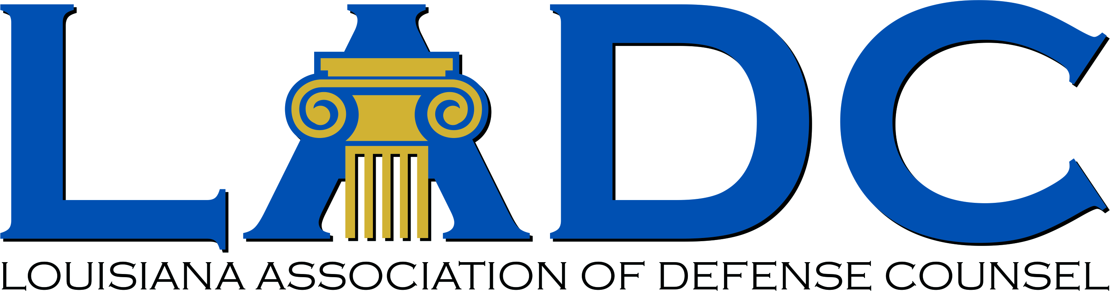

Louisiana Judicial College and
Louisiana Association of Defense Counsel Joint Seminar
The Roosevelt New Orleans - Friday, Dec. 6, 2019

7:30-8:30 am Registration Waldorf Astoria Foyer
Breakfast Conti/Lafitte Room (Mezzanine Level)
8:00-8:15 am Welcome Remarks
8:15-9:15 am “Where Everybody Knows Your Name”: The Shrinking Realm of Privacy
Professor Amy Gajda, Tulane Law School
Prof. Bill Corbett, LSU Law Center, LADC Executive Director

9:15-10:15 am The Biggest Game in Town: Current Issues in Louisiana Tort Law
Dean Tom Galligan, LSU Law Center
H. Alston Johnson III, Phelps Dunbar

10:15-10:30 am Break

10:30-11:30 am Tort Recovery: "Not So Fast, My Friend”: Medicare Secondary Payer Regulations
Bruce Cranner, Talley, Anthony, Hughes & Knight
Judge (retired) Carolyn Gill-Jefferson, Aaron & Gianna
J. Neale deGravelles, deGravelles & Palmintier

11:30-12:30 pm Ethics Prof. Dane Ciolino, Loyola University New Orleans College of Law

12:30-1:30 pm Buffet Lunch Crescent City Ballroom (Mezzanine Level)

1:30-2:30 pm “May I be Excused?”: Issues in Recusal.
Judge Nakisha Ervin-Knott, Orleans Parish CDC
Judge William Morvant, 19th Judicial District Court
Gene Fendler, Liskow & Lewis, APLC
Lauren McHugh Rocha, General Counsel, Louisiana Supreme Court

2:30-3:30 pm Updates on Insurance and UM Waivers
Skip Philips, Taylor Porter
Judge Allison Penzato, First Circuit Court of Appeal

3:30-3:45 pm Break

3:45-4:45 pm Professionalism Michael H. Rubin, McGlinchey Stafford

CLE will be located in the Waldorf Astoria ballroom – Mezzanine Level

