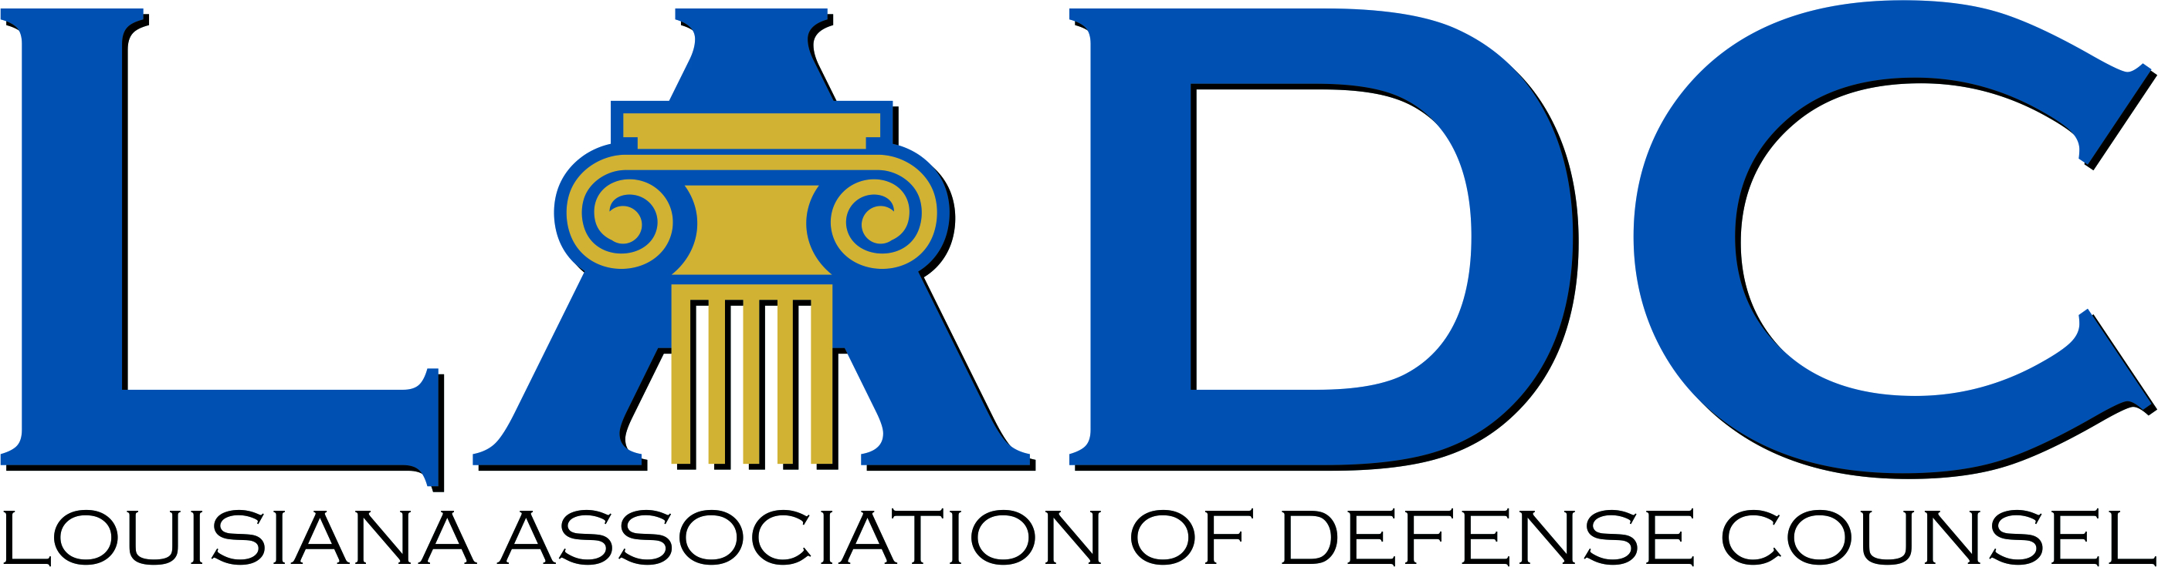****

**Louisiana Judicial College and**

**Louisiana Association of Defense Counsel Joint Seminar  
The Westin New Orleans - Friday, Dec. 12, 2025**

7:30-9:00 am ***Registration*** & ***Breakfast***

8:00-8:15 am **Welcome Remarks:**

Judge Anastasia "Staci" Wiley, *President of the Board of Governors,*

*Louisiana Judicial College* and

S. Dennis Blunt, *President of the LADC*

8:15-9:45 am ***Recent Developments in Louisiana Civil Procedure (1.5 hours)***

Judge Tiffany G. Chase, Louisiana 4th Circuit Court of Appeal

Judge (Retired) Guy Holdridge, Director of the Louisiana State Law Institute

James K. Ordeneaux, Plauché Maselli Parkerson, LLP

Prof. Bill Corbett, LSU Law Center

9:45-10:00 am **Break**

10:00-11:30 am ***Recent Developments in Louisiana Tort Law (1.5 hours)***

Justice Piper D. Griffin, Louisiana Supreme Court

Prof. Thomas C. Galligan, Jr., LSU Law Center

Thomas M. Flanagan, Flanagan Partners, LLP

Prof. John M. Church, LSU Law Center

11:30-12:30 ***Torts and Artificial Intelligence (1 hour)***

Prof. Jane Bambauer, Levin College of Law University of Florida and Brechner Eminent Scholar Chair, College of Journalism and Communications

12:30-1:30 pm ***Buffet Lunch***

1:30-2:30 pm ***Updates on Insurance Law (1 hour)***

Judge Allison H. Penzato, Louisiana 1st Circuit Court of Appeal

Harry J. “Skip” Philips, Taylor Porter

2:30-3:30 pm ***Professionalism: The Unwritten Rules of Talking to a Jury (1 hour)***

Judge Stephen D. Enright, Jr., 24th Judicial District Court

Judge Stephen C. Grefer, 24th Judicial District Court

Lottie L. Bash, Faircloth Melton Bash & Green, LLC

Rachel G. Webre, Laborde Siegel, LLC

Chris Whittington, Williamson, Campell & Whittington, LLC

3:30-3:45 pm Break

3:45-4:45 pm ***Ethics (1 hour)***

Judge Laurie A. Hulin, 15th Judicial District Court

Prof. Dane Ciolino, Loyola University New Orleans College of Law

**7 Total Credit hours**