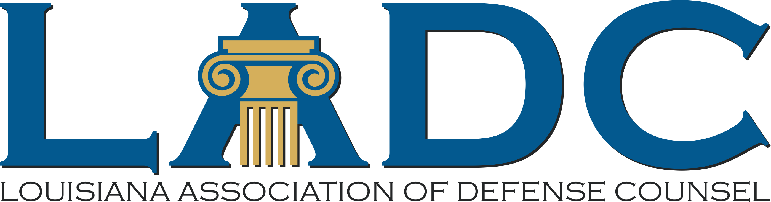

LADC’S FRANK L. MARAIST AWARD
ELIGIBILITY, PURPOSE, and CRITERIA

This award recognizes a young lawyer who:
- Is admitted to practice in Louisiana and is in good standing;
- Is 39 years old or younger or in practice for six or fewer years;
- Demonstrates professional excellence;
- Demonstrates service to the profession and the bar;
- Demonstrates commitment to pro bono work and community service; and
- Demonstrates contributions to furthering the ideals of the legal profession.
All nominations must include a completed LADC Frank L. Maraist Award nomination form and a brief synopsis of no more than 200 words explaining why the nominee is deserving of the Frank L. Maraist Award. Self-nomination is encouraged. The entire nomination packet should not exceed 10 pages.

Membership in LADC is not required to be nominated; however, the winner must be an LADC member at the time of award.
LADC’s Young Lawyers Committee will assess the nominees based on professional excellence, service to the profession and the bar; service to the community, and reputation for or advancement of legal ethics and professional responsibility.
LADC’s Young Lawyers Committee will select five finalist from our member districts based on the nomination forms. These finalists will be recognized at the Awards dinner along with the other nominees. The LADC’s Young Lawyers Committee will recommend a winner from the district finalists to the LADC’s Board of Directors, who will have the ultimate authority and discretion of selecting the winner of the Frank L. Maraist Award. The Frank L. Maraist Award will be presented during the LADC’s Awards Dinner on August 5, 2021.

THE COMPLETED NOMINATION FORM AND SUPPORTING MATERIALS MUST BE EMAILED*, FAXED (504-208-5512), OR POSTMARKED BY JULY 2, 2021.

Louisiana Association of Defense Counsel
P.O. Box 9430
Metairie, LA 70055-9430

Dates To Remember
Open nominations – May 3rd
Deadline for nominations – July 2nd
Announce finalists - July 12th
Awards Ceremony – August 5th

*Please note the committee encourages electronic submission of nominations. Email forms to kimberly@eventresourcesnola.com

